GUÍA DIGITAL N°1 Worksheet
Unit 1” Information and Communication Technologies”
UNIDAD 1 “INFORMACIÓN Y TECNOLOGÍAS DE COMUNICACIÓN”
DOCENTE: MARÍA KARIME CHIETO
ASIGNATURA: INGLÉS
CLASS: CURSO: 8TH GRADE
DATE: APRIL, 2020

OBJETIVOS DE APRENDIZAJES :
- Presentar la nueva unidad.
- Usar presente simple, much or many and wh words.
- Demostrar compresión de un dialogo relacionado con la tecnología.

Tips

>Enfócate en lo que vas a realizar.

>Responde esta guía de autoprendizaje con responsabilidad.

>Asegúrate de leer bien antes de comenzar a responder

>Marca solo una alternativa y responde con letra clara cuando escribas en tu cuaderno.

>Ten confianza. Éxito!

- Read and unscramble the words related to tehnology.
- mCpetoru= ____________________________________
- oesuM=_______________________________________
- Pgul=_________________________________________
- eennotcCd=____________________________________
- . tgihL=________________________________________
- notecCn=______________________________________
- rtPo=__________________________________________

- Reading Comprehension
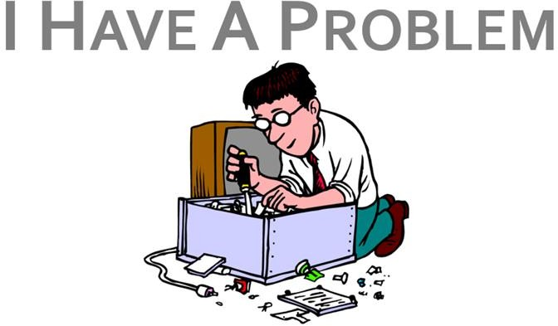
A: Good Morning! Alpha-Tech. This is Andrew. How can I help you?
B: Good morning Andrew! This is Lucas. I have a problem with my computer.
A: O.K. Lucas! Tell me. What problem do you have with your computer?
B: The mouse doesn´t work.
A: Is it just the keys that don´t work or it doesn´t even move? B:No, It doesn´t move
A: Check whether the light is on or off! B: It is off.
A: Check if it is connected to the U S B port!
B: Oh! Here it is. The wire was not plugged. My mouse is working now!
A: That´s good! Is there anything else I can help you with? B: No that´s all.
A: O.K. Then, I hope you have a nice day and don´t doubt to call us anytime.
B: Thank you. Good-bye

- What type of the text…
- an interview
- a dialogue

- What the purpose of the text…
- ask and answer about technology.
- offer a product.

3. Read and decide whether the following sentences are True (T) or False (F) (Lee y decide si las oraciones siguientes son verdaderas o falsas).

- The conversation is a face-to-face talk.
- Andrew has a problem with his computer.
- The mouse doesn´t work.
- It doesn´t work because it is not plugged.
- Lucas is happy by the end of the call.

- What do you do if you have a problem with your computer?(¿Qué haces tu si tienes problemas con tu computador?)

- I send it to the technical service.
- I check it myself.

